VPN Connection – iPod – IPhone - MAC
Before you start you will need the following information:
PDS Connection setup
PDS_Server_IP:
Your_PDS_User_Name:
Your_PDS_Password:
VPN Setup is required if you wish to use PDS form other locations (travel).
VPN_Server_IP:
VPN_USER_NAME (this could be the same as your PDS user name):
VPN_PASSWORD (this could be the same as your PDS password):

We recommend leaving the rest of the stings on default or “auto”. Please call us if you need any of the information above (480-464-6053).

PDS Connection Setup:
(pTerm - SSH, Telnet Client and Terminal Emulator)

Please download the following program “pTerm” by the (ITUNES) Application Store feature: http://itunes.apple.com/us/app/pterm-ssh-telnet-client-terminal/id287269552?mt=8

Please install and then run the pTerm program (after installation you will find it on the desktop by scrolling to applications.)

+

- After you click on the + sign (see above) you will have the below screen where you can fill out the required parameters.
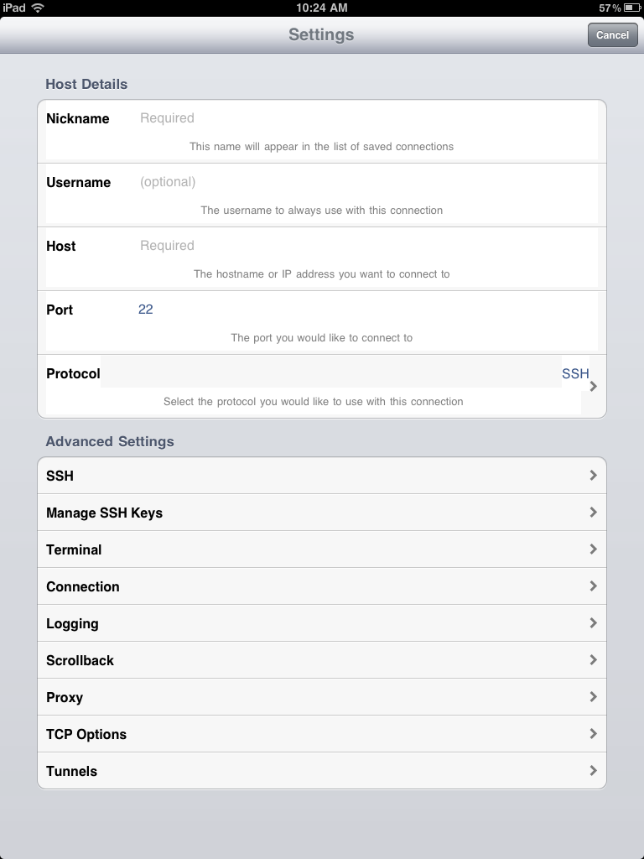
PDS_USER_NAME
PDS_SERVER_IP
Company Name
(Full program documentation: http://itunes.apple.com/us/app/pterm-ssh-telnet-client-terminal/id287269552?mt=8 )

VPN Setup:
- Double click the “Settings” icon and click on General as you see in the below figure
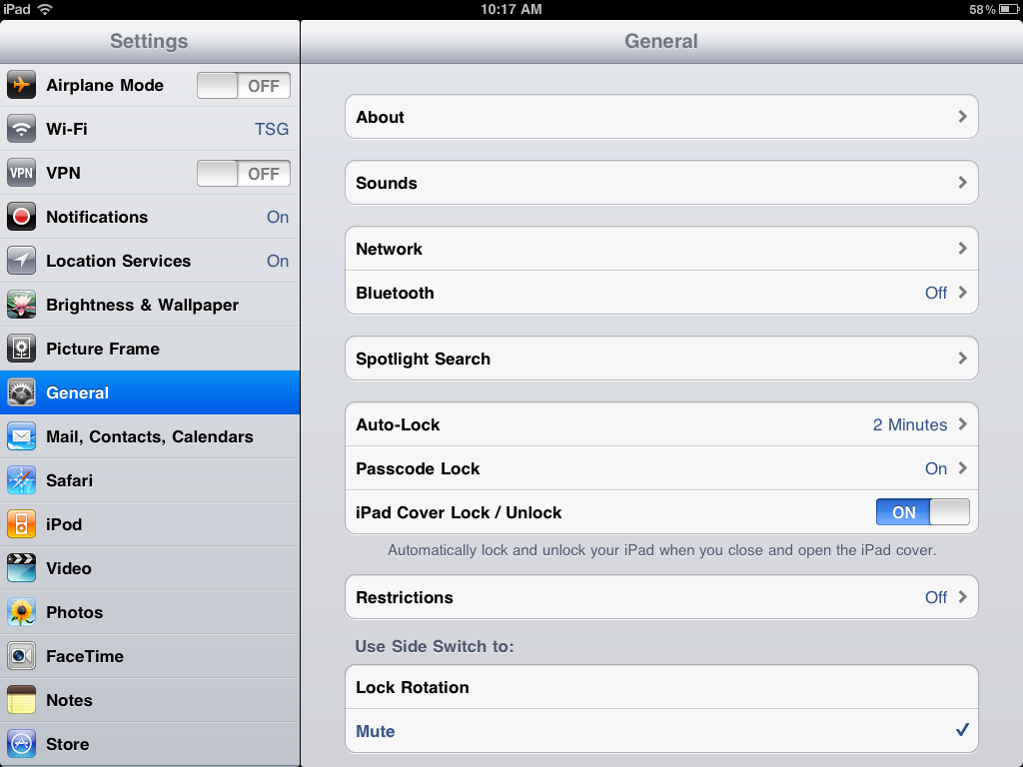
- Click on the VPN option right side that will take you the below figure
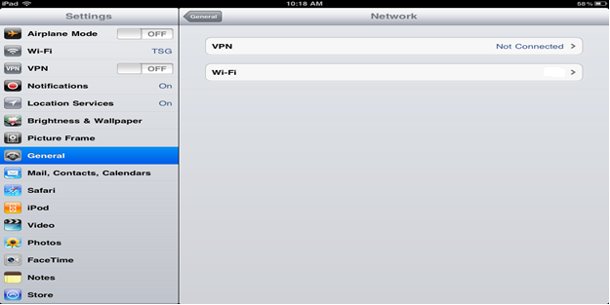
- When you select the VPN option you will see: ” Add VPN Configuration…”
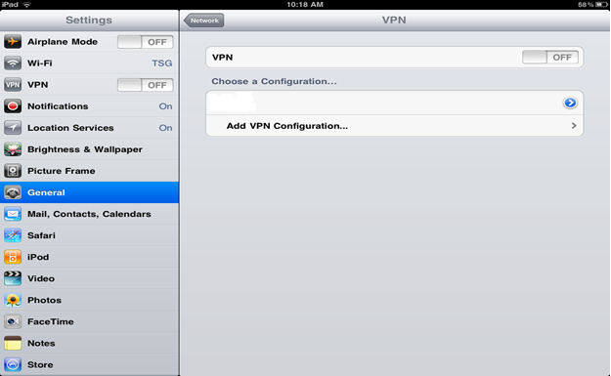
- After you click on “Add VPN Configuration” you will get the child window below where you specify VPN_”Server”_IP and VPN_User_Name/Password
(“Account” information).
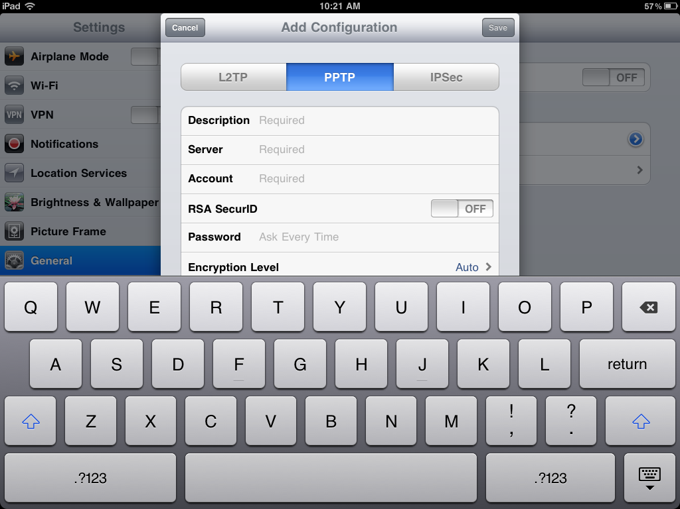
How to use:
If you are in the office make sure that you’ve connected to the local Wireless network. Then start the pTerm program.
If you are travelling or only 4G Internet (cell phone Internet) is available. Make sure that you have connected to 4G or other networks that provide Internet. Then connect to the VPN connection than start the “pTerm” program.
The VPN connection can be started or disconnected by clicking “Settings” -> VPN Section -> Connect.
Notes:
VPN – Stands for Virtual Private Networking. If you connect it virtually places you to the office. So the user can access programs and devices such as PDS.
pTERM- Is a program like DejaWin or Putty for MAC devices. 3rd party tool you can only buy it through your IPhone (ITUNE) device.
IP or User Name:
On most systems this is known by the user. However it is not used every day. If you need these information’s please give us a call and we can look that up for you.
Issues:
With IPHONE technical or software issue we recommend to contact your provider first, because they offer free support and trained professionals can assist you with the requirements. However if you have issues with the user name or IP’s or the connection itself we are more than happy to advise and assist even if it’s a 3rd party provider issue.

Jamil/KP/PRX 2012

