In the APP store search for "FileBrowser Access"
http://itunes.apple.com/us/app/filebrowser-access-files-on/id364738545?mt=8
(This is the program and icon and description. We need to find the same in the APP store.)
Once you've purchased the program. Open it and on the left side next to "Locations" you will see a "+" plus sign. Tap in the "Address" field and type: smb://192.168.x.x (PDS server IP)
On the "Show More Settings" slide the switch to "ON".
"User Name" field type the PDS user name. (Or the common samba password)
"Password" field type the password.
Then Click "Save" in the right upper corner.
This will create a shortcut on the left under "Remote Files". If we click that we can browse the shares. (If the browsing doesn't work verify the user name password.)
Once it’s done we just need to tell the users to click on "FB" on the desktop than "Remote Files".

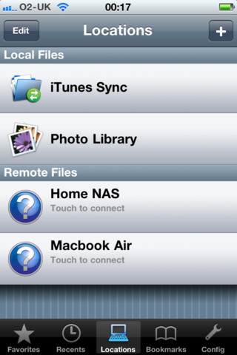

PRXKP2012

