Creating SMTP2GO Email Reports
This is a new feature. Resolution for Email tracking, clean up invalid/outdated contacts, avoid miss categorized spam listings, debug/review PDS Email features, etc… In PDS we can verify outbound documents. However in most cases we can only see if the document was accepted for delivery. This is common to every Email systems (99%) they only show that the Email was sent. It was time taking to find out what happened to individual Emails… It’s like asking the postman what happened after the mailbox. Well tracking is a solution. However most Email systems categorize that as spam or hacking. So there is a new global standard that reports if the Email was returned by the reasons listed above. For PDS (SCO/LNX) it takes a very short time to integrate/test a new service by SMTP2GO. This service is a small yearly fee by SMTP2GO. Once it is integrated you can do billing directly if required. The system has a nice and understandable WEB interface. It also sends easy to understand Email reports. It takes about a week to reach 99% delivery rate, by knowing the Email issues.
- Click the following link: http://www.smtp2go.com/ Click “Log in” near the upper right corner. Enter the correct user name and password in the fields provided.
- Under the “Reports” tab you see Summary, Email Details, Spam Reports, etc.
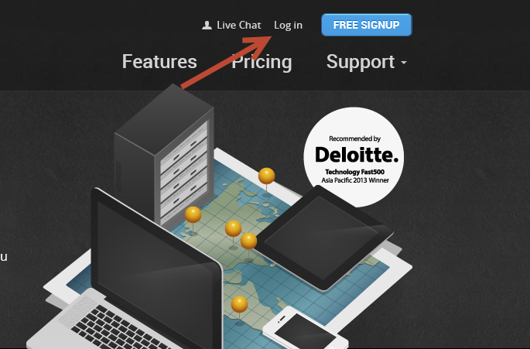
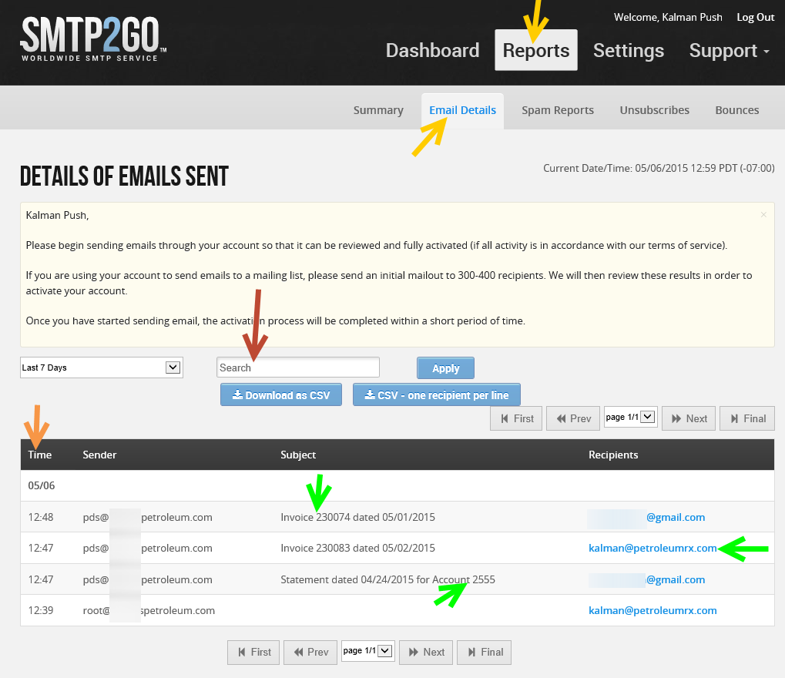

Under “Email Details” we can see all of the delivered Emails. If we see an Email listed in here the delivery was successful guaranteed. So if a customer calls it is now easy to verify. We can search/narrow the list by Account, Invoice number, STMT number, EFT, Email address, etc… We can also verify the delivery date/time (To ensure/prove that the document has arrived in time).
This list only contains delivered items. If there was any bounce message or notice or if the customer tagged the Emails as spam or have hosting issues. The Emails will go to “Bounces” or “Spam Reports”. Since SMTP2GO is a well maintained service it is rare to see items in these other reports. But if we just integrate we might have items in there due to past issues that has never been resolved/known. (outdated contacts, client side hosting issues, etc..). In a week it is possible to reach 99% success delivery rate.
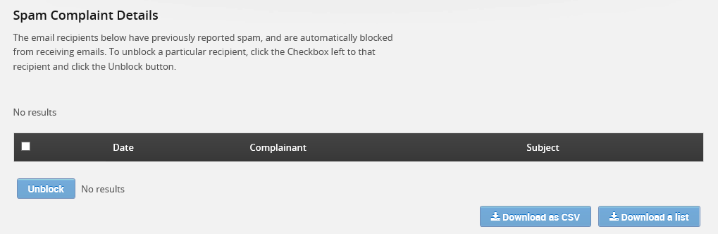
“Spam Reports” In the hosting industry the biggest issue is that we can end up on a spam list by a single unattended or miss categorized Email. In minutes multiple spam filters can start a global blocking campaign and no one will receive anything. If that happens administrators have to dig out multiple spam listings and ask/hope for removal. It usually takes 48h for the removal. If the admin misses one it can restart the chain… Literally can take weeks to resolve. There was no real solution to avoid this up until now! If a customer tags the PDS Email as spam. It will go to the “Spam Reports” list. Which is good, because we never known in the past who and why/how. Now we have a report to tell us. If we see an Email in the report we must contact the customer to resolve the issue. The good news is that SMTP2GO will hold (new) Emails to this customer up until we are confident that the customer will not tag it again. If they are notified and we can trust sending Emails to them. We can click “Unblock” Checkbox next to the Email line. If by chance the customer couldn’t resolve the issue. Their outbound Email will gets tagged again and SMTP2GO will hold delivery until they resolve. By this the Emails will never end up on global spam listings. A mistake/misunderstanding will not affect other customers. To double ensure. SMTP2GO monitors spam listings to avoid any technical issues. Even if there is an issue at least we would know in seconds by looking at the “Spam Reports” tab.
“Bounces” If we see Emails in here most of the time it is a customer hosting side issue that the customer might not even known. Common issues: Invalid Email address, Customer has quota, doesn’t accept attachments… If we know the issue at least we don’t have to wonder we are dealing with a global issue, time delay, pds… And it is an easy way to make the customer happy by sharing that his mailbox might be low on disk space…
SMTP2GO has many other features. Such as “Do not disturb/unsubscribe”… The interface does not change PDS or PC or delivery settings so it’s easy to use. It is an Email relay so I can help to integrate it with other 3rd party software's. Real-time demo is possible. Please contact us for details.
PRXKP2015

